

Submitted By
Student Name | Manyata Goswami
Roll No | 24/SCA/BCA(AI&ML)/037
Programme | BCA (AI&ML)
Semester | 5th
Section/Group | C
Department | School of Computer Applications
Session / Batch | 2024-27
Submitted To
Faculty Name | Dr. Sakshi Gupta

Q1. Introduction to Networking Tools and Hardware
Aim:
To identify and demonstrate the use of common networking devices such as switches, routers, hubs, and network cables.

Requirements:
• Cisco Packet Tracer
• PCs
• Switch
• Router
• Hub
• Copper Straight-Through Cable
• Copper Cross-Over Cable

Answer:
A Hub connects multiple devices and broadcasts data to all connected ports.
A Switch connects devices in a LAN and forwards data to the intended device using MAC addresses.
A Router connects different networks and forwards packets using IP addresses.
A Straight-Through Cable is traditionally used to connect dissimilar devices such as PC-to-Switch.
A Crossover Cable is traditionally used to connect similar devices such as PC-to-PC or Switch-to-Switch.

Procedure:
1. Open Cisco Packet Tracer.
2. Place PCs, a switch, a hub, and a router in the workspace.
3. Select the appropriate cable from the Connections menu.
4. Connect PC to Switch, PC to Hub, and Switch to Router.
5. Wait for the link indicators to become active.
6. Observe the communication between the connected devices.

Result:
The common networking devices and cables were successfully identified and their basic uses were demonstrated.

Q2. Implement different topology in Cisco Packet Tracer.

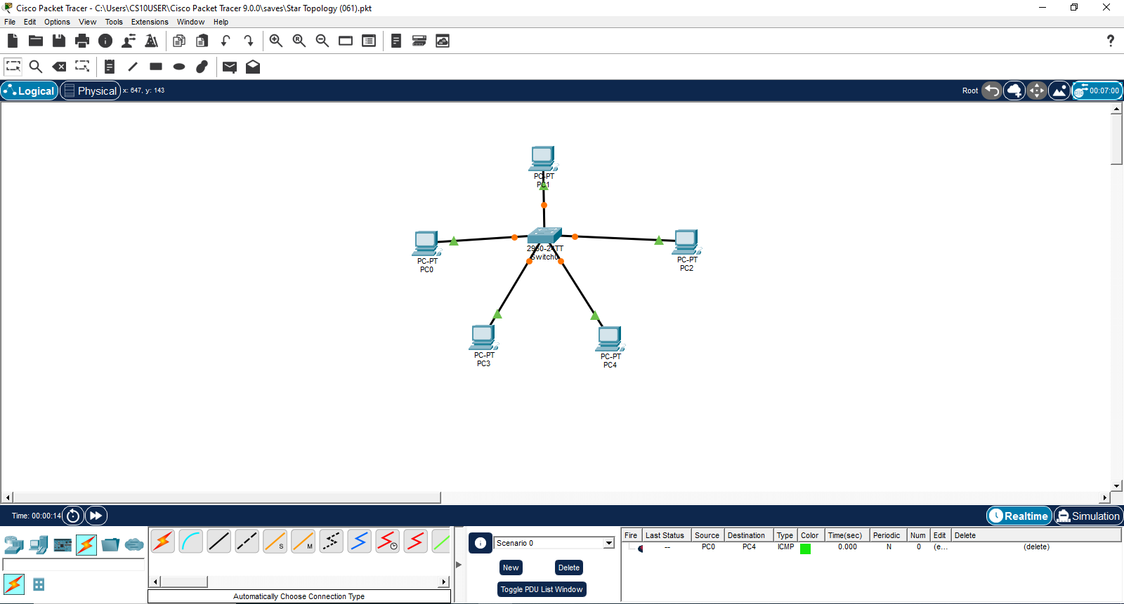
- STAR TOPOLOGY:

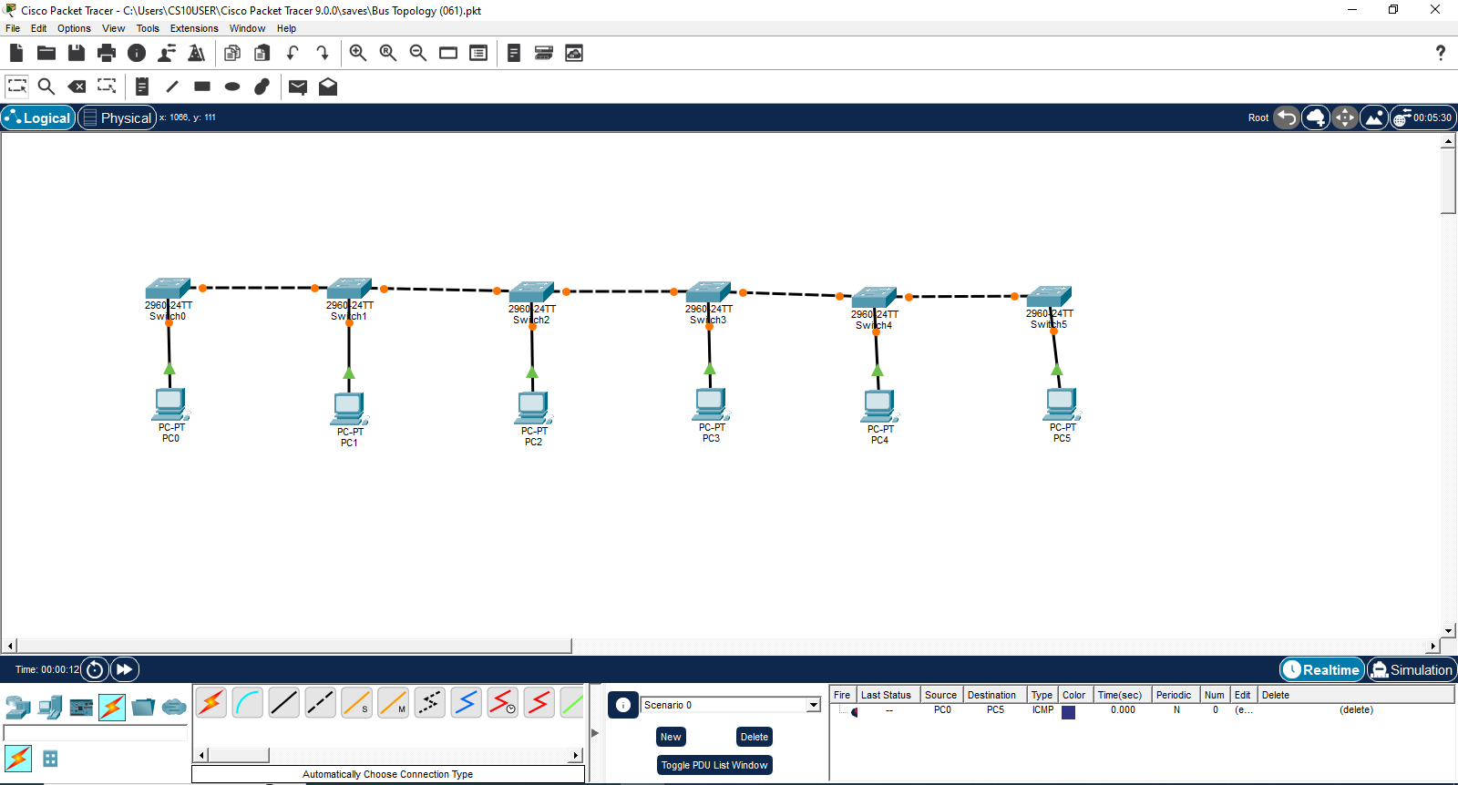
- BUS TOPOLOGY:

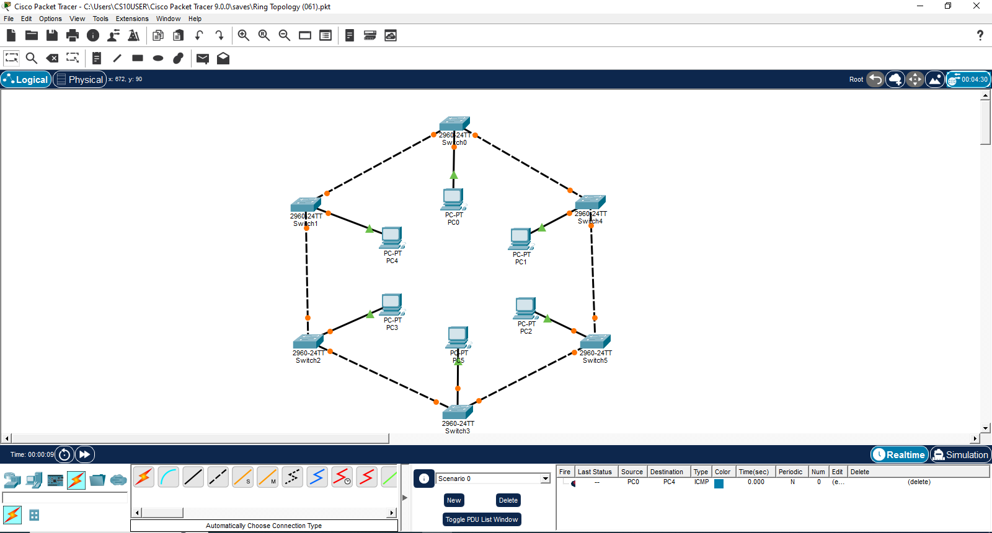
- RING TOPOLOGY:

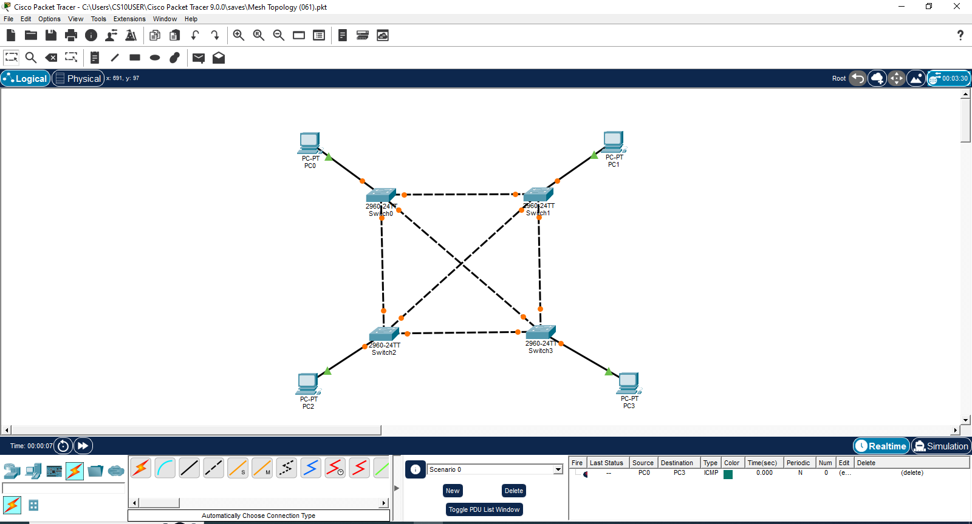
- MESH TOPOLOGY:

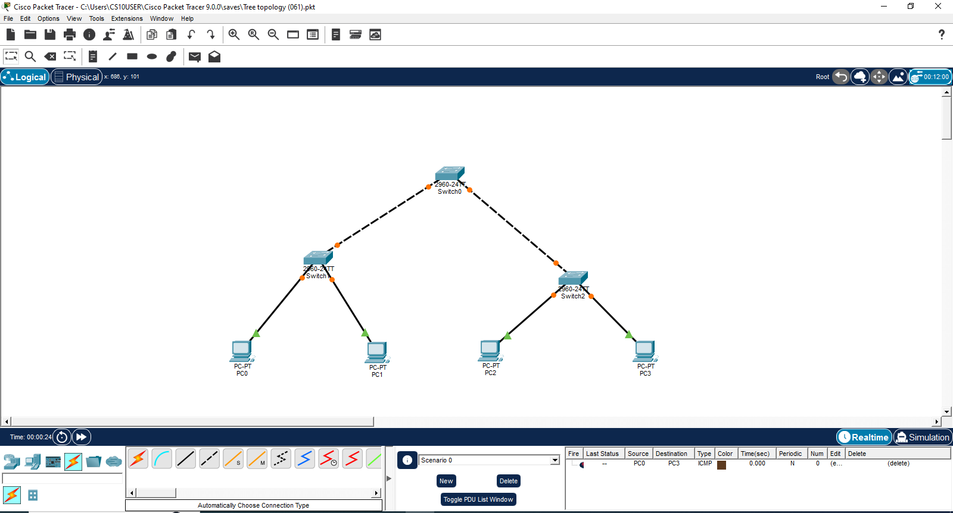
- TREE TOPOLOGY:

Q3. Implement the appropriate use of crossover and straight- through cables to connect similar and dissimilar devices in Cisco Packet Tracer.
Output –

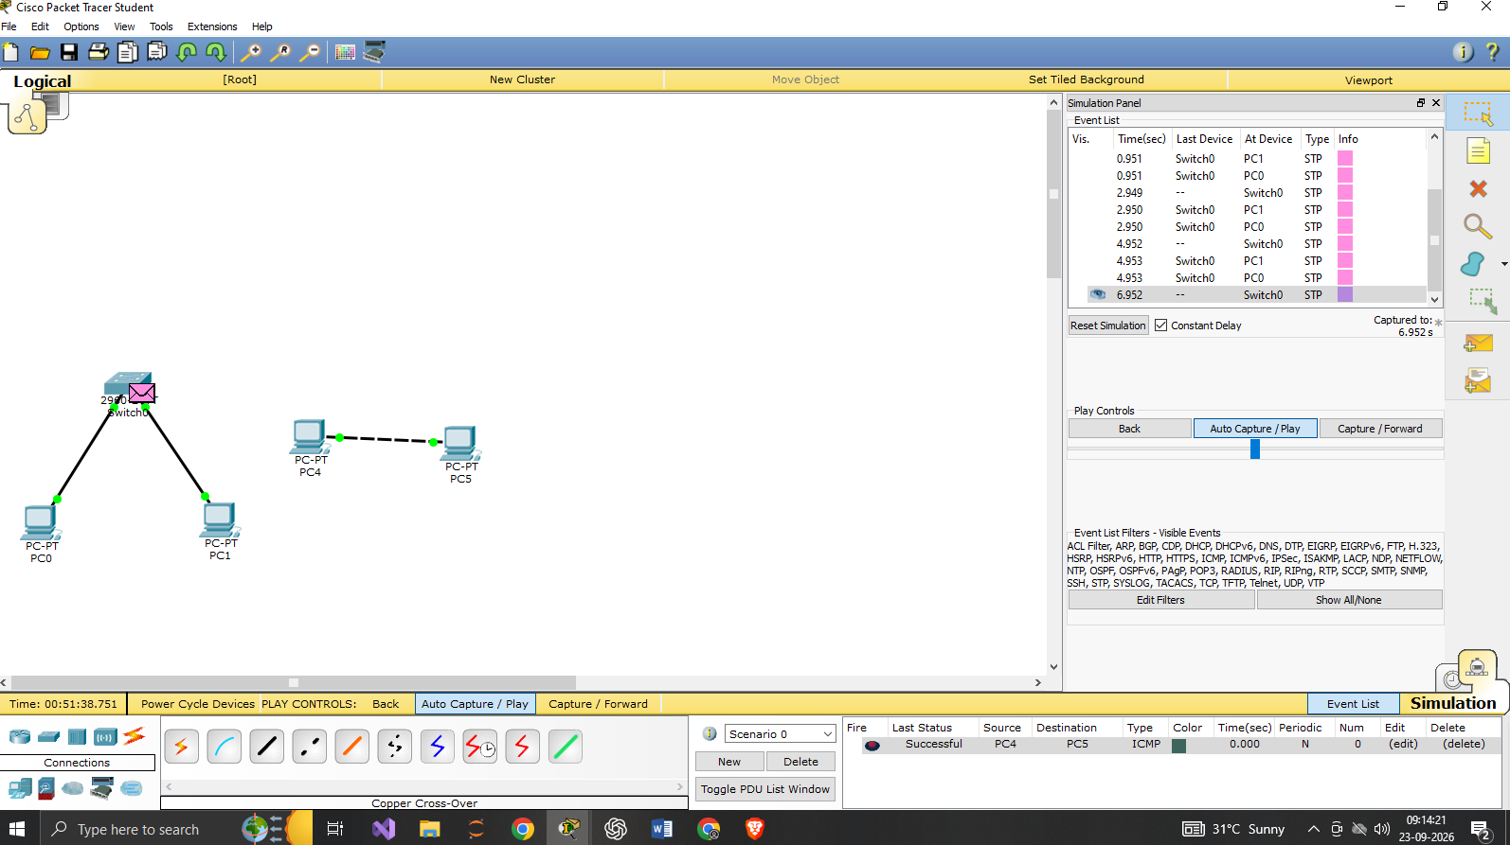

Q4. Implement the configuration of two LANs interconnected through a router using a network simulation tool to apply concepts of IP addressing and routing.

